Jacob Lee

CS 340

April 16, 2021

README CS 340 Project Two

**Functionality**

The purpose of this application is to display data about dogs in animal shelters with a simple user interface. Grazioso Salvare has a database of dogs in shelters that are candidates for search-and-rescue training. This Plotly Dashboard displays information about the dogs in a table and a map. The data can be filtered based on user needs. The data is stored in a MongoDB database. MongoDB was chosen because it provides flexibility when developing the codebase for querying and displaying the data. The codebase for the dashboard was implemented using Jupyter Notebook and Python language. This type of code does not require compiling and makes it easy to create new iterations of the program quickly. The MongoDB database is accessed using the Python dashboard front end user interface. Correct credentials must be used when accessing the database for authentication.

**Images**

Below are images showing the window used to filter data. Clicking one of the radio buttons will filter the results shown in the table.

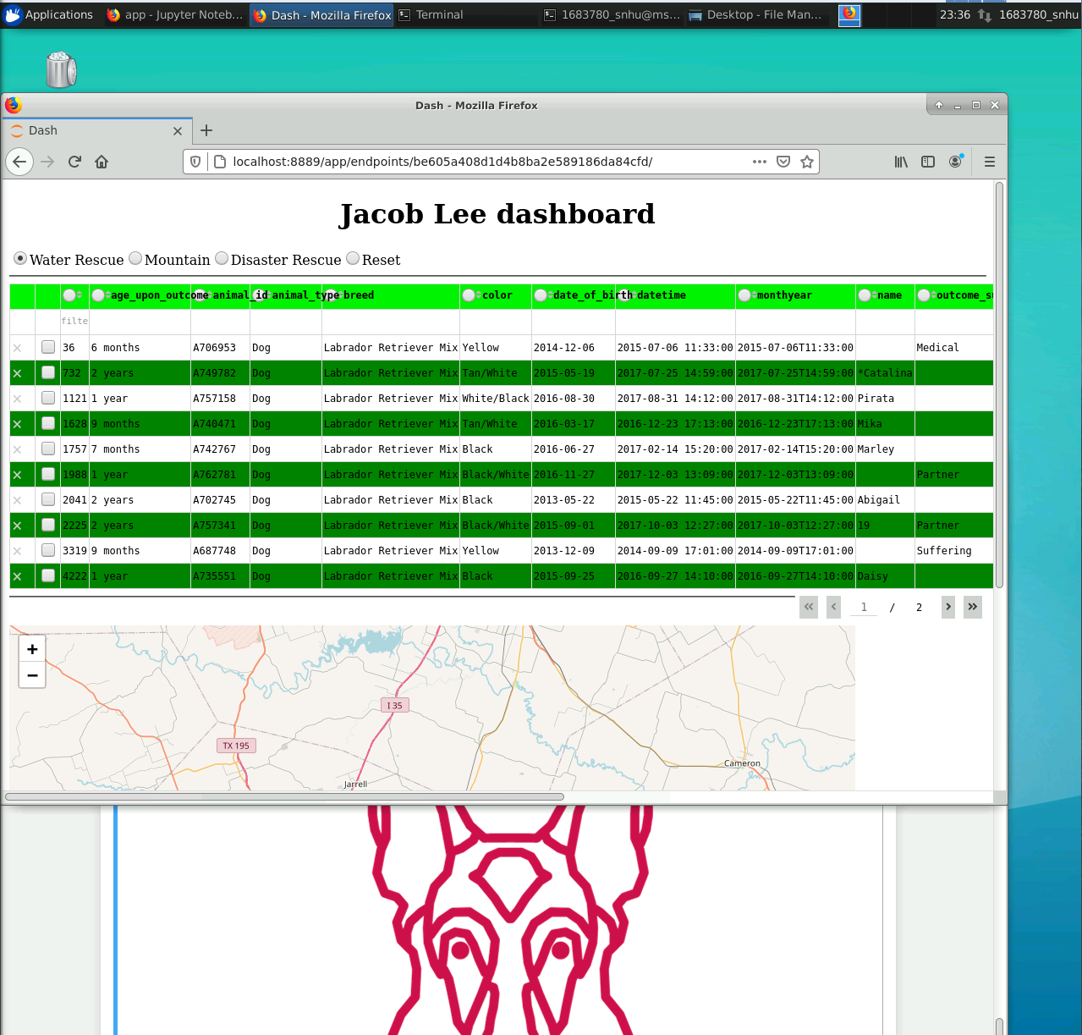

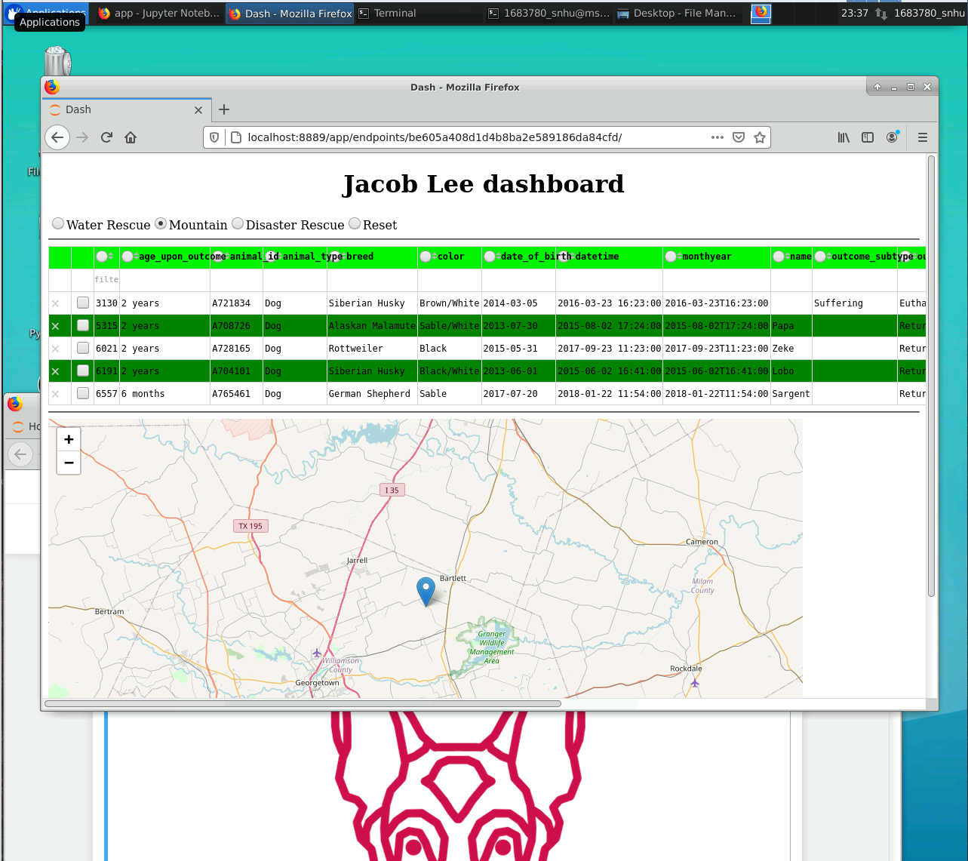

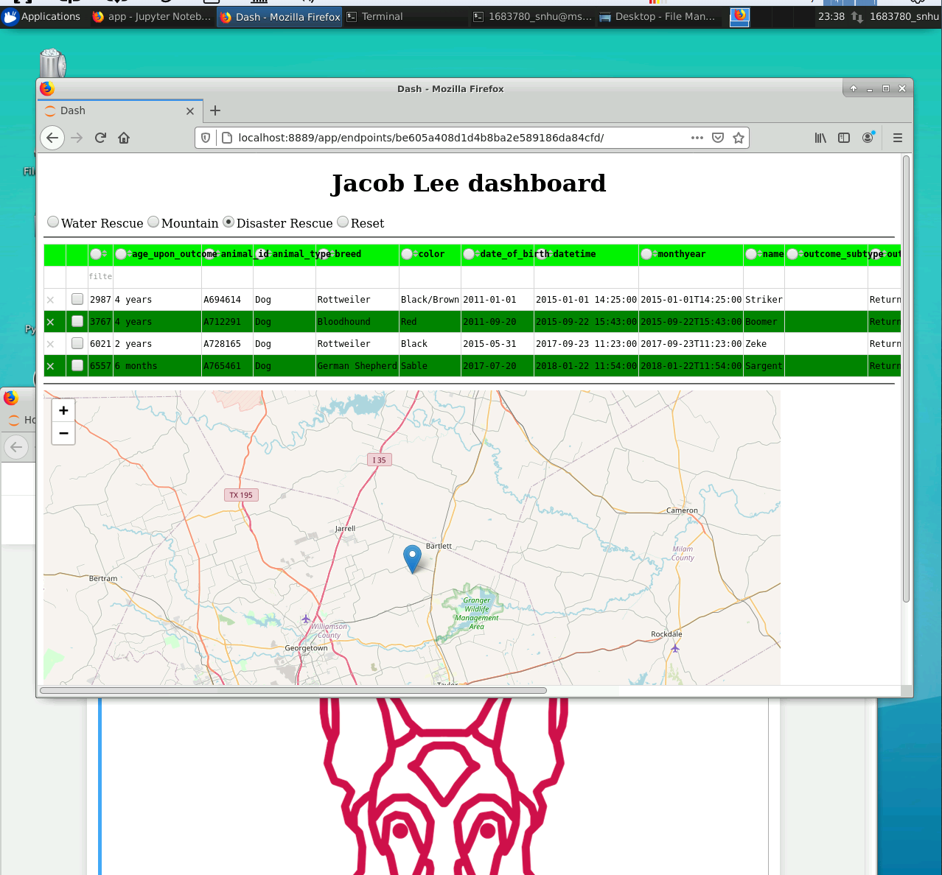

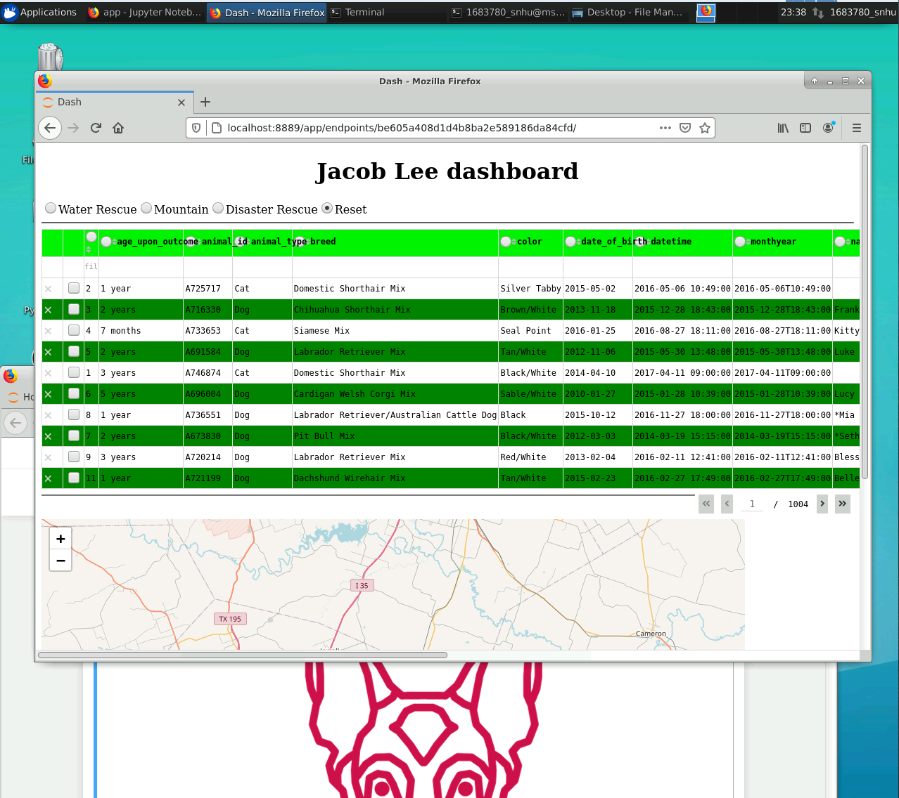

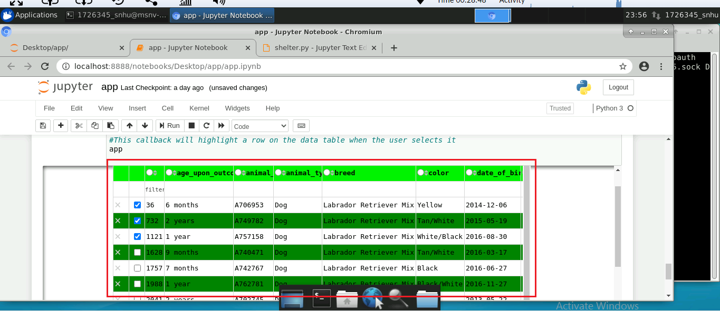

Additionally, the dashboard displays a map showing the dog’s location and details.

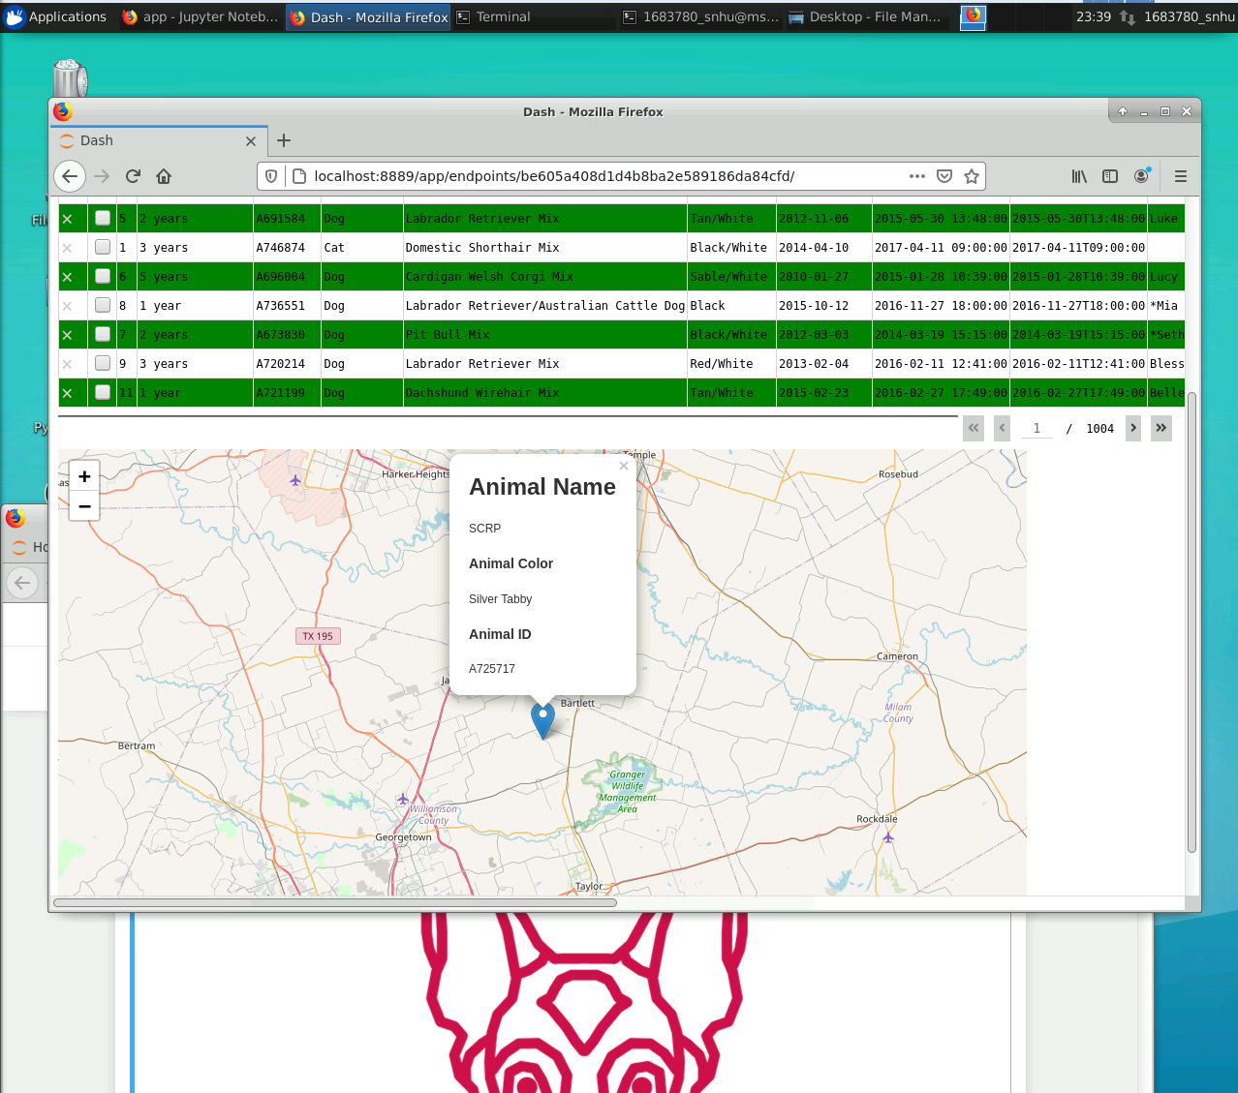

Steps followed.

1. For new users, tools that need to be installed include Jupiter Notebook, MongoDB database, and Python 3.
2. The second step is to create a database in MongoDB and create an account to authenticate access.
3. The new database should now be populated with data.
4. After the database is created, a Python script should be created to login to the MongoDB database. This script should be able to Create, Read, Update, and Delete records from the database.
5. Finally, the front-end dashboard should be created to format the data retrieved from the database and allow the user to filter the results.

Challenges

Some challenges that were encounters during this project was getting the MongoDb database to respond to the Python script. Its important that an instance of MongoDB is running anything a user wishes to access the database. Also, writing the front end dashboard code was tricky, but following some Plotly tutorials online should help with learning the syntax.